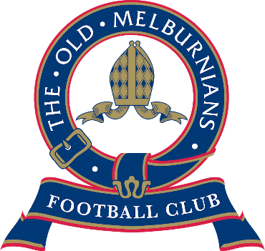
Celebrating 100 Years

THE OLD MELBURNIANS FOOTBALL CLUB
U/19’s COACHING POSITION

SECTION: | VAFA – U/19 DIV 1
TITLE: | U/19’s COACH
REPORT TO: | THE OMFC COMMITTEE

The Old Melburnians Football Club (OMFC) is seeking applications for the position of U/19s Coach in U/19 Division 1 of the Victorian Amateur Football Association (VAFA).
The OMFC will celebrate its 100th year in 2020 and will be looking to further strengthen the development of its U/19s program after winning the premiership in 2019. The club currently has a very talented playing list that is eager to learn and develop, determined to achieve team success.
The OMFC has also recently moved into its new $6.4m facility at Elsternwick Park and arguably has the best facilities of any team in the VAFA.
Applicants for the U/19s coaching role will need to demonstrate the following to be considered:
- A passion for driving a fun, strong and inclusive club culture across all teams
- A well-developed game plan to be implemented with a clear and consistent approach supported by prior success
- A structured, organised and disciplined approach to both training sessions and games
- A strong educator who is an excellent communicator both on & off the field who values player/personal development
- Level 1 AFL Victoria coaching accreditation (or willing to attain)
Remuneration offered will be competitive and reflective of the skills and attributes of the selected applicant.
Please provide a cover letter & resume outlining your experience to Club President Chris Wischer and note that all applications will be treated in strict confidence.
Applications to be lodged via email omfc1920@gmail.com by Thursday 15th of November 2019 at 5pm.

